Green Society Public School
D-24
Ratnanagar-7, Sauraha, Chitwan
Third Terminal Examination-2082
Class: Nursery Time: - 2 hrs. F.M.: 50
Sub: Rhymes and Conversation
- What is your Name? [5]
- How old are you? [5]
- In which class do you read? [5]

- Identify the picture? [5]
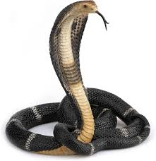

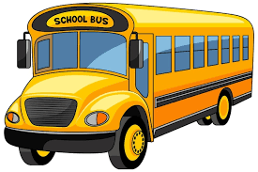

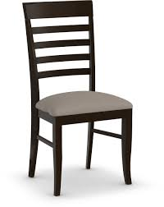

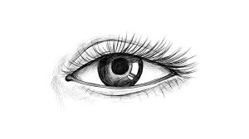

- Rhymes. [5]
- Dance [5]
- Neat and clean [10]
- Regularity [10]
The End

